Tasks on RDS
- Create MariaDB DB on EC2.
Connect to one instancesudo suusing command dnf install mariadb105-server -y command to install
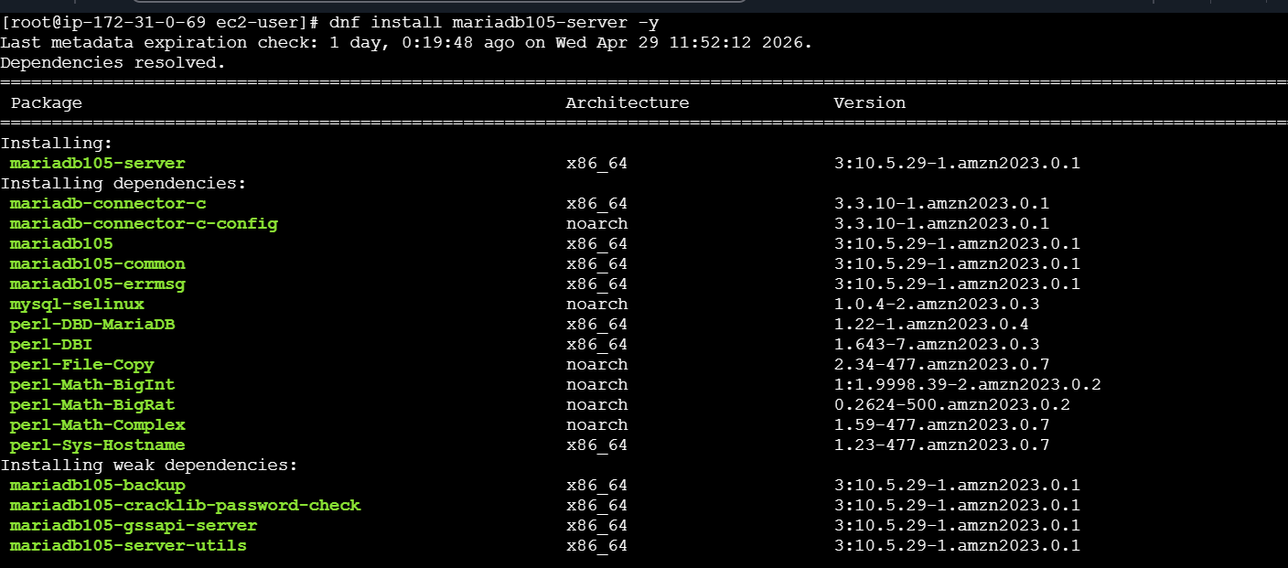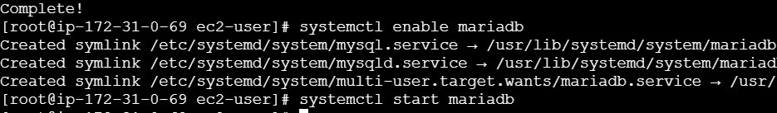
- Installed mariaDb Server
- Using these command we will enable and start the service
- systemctl enable mariadb
- systemctl start mariadb
- yum -y update

- Insert some dummy data.

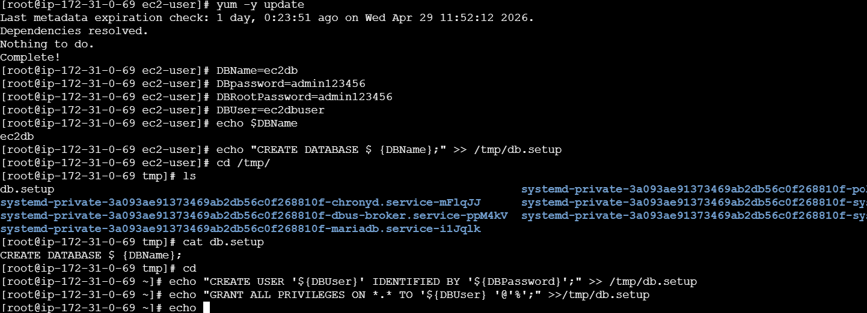
- Set Environmental Variables
- Setting the admin and password and logging in to MariaDb
- DBName=ec2db
- DBPassword=admin123456
- DBRootPassword=admin123456
- DBUser=ec2dbuser
- mysqladmin -u root password "${DBRootPassword}"
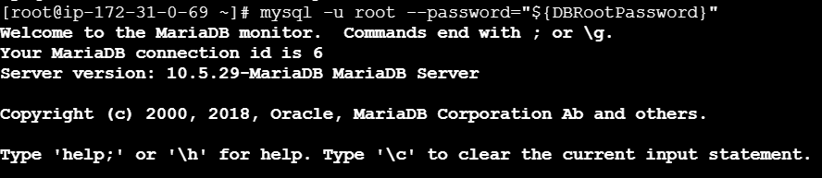
Use dbec2;I don’t get because don’t then I want SHOW DATABASES TO SEE THE data
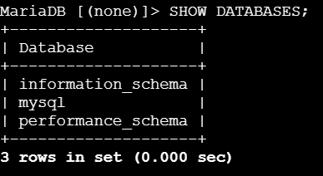
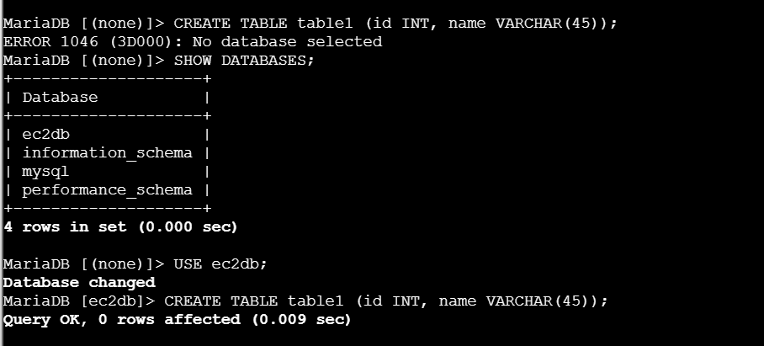
- USE ec2db; to change to the newly created database→create database ec2db;
- Below commands have been used to create and insert the data into the tables.
- CREATE TABLE table1 (id INT, name VARCHAR(45));
- INSERT INTO table1 VALUES(1, 'Virat'), (2, 'Sachin'), (3, 'Dhoni'), (4, 'ABD');
- SELECT * FROM table1; 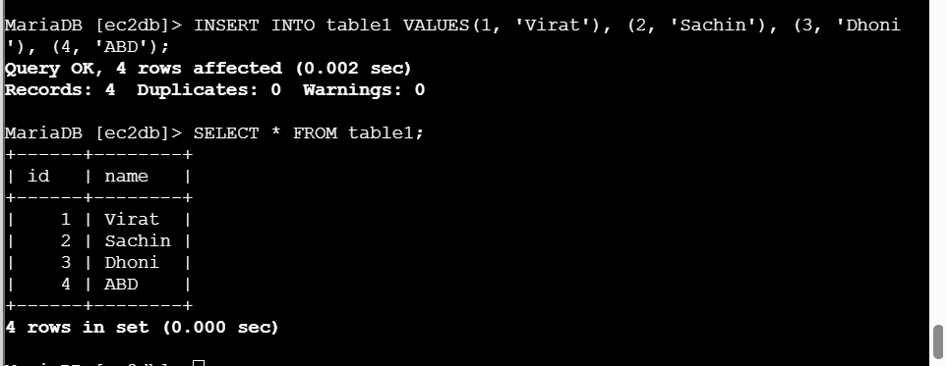
- Take the backup of dummy data on EC2.
- Created a dump by using mysqldump utility
- But before that we need to come out from mariadb to our instance and we need to execute
- the command on ec2 level so that we can backup on EC2
- mysqldump -u root -p ec2db > ec2db_dump.sql
p-password,-u username -h host
>symbol represents the redirect to backup then enter password give we see our data is backup successfully.
- Launch MariaDB RDS instance.
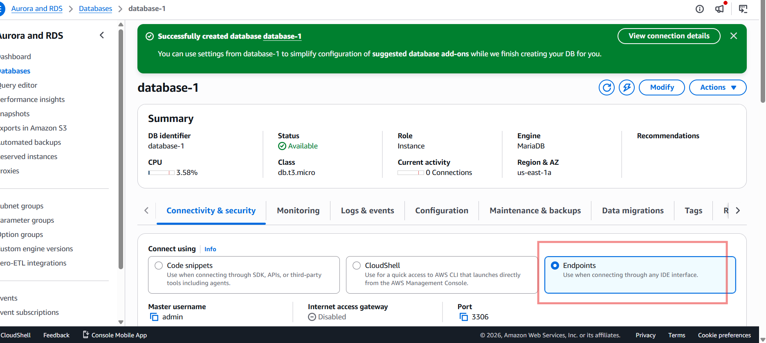
- For that got RDS Create Database Full Configurations→
Mariadb engineversion Templates Settings Name Credential Settings Master
username password Instance config storage storage autoscaling(NO) Availabilty
andduarability Multi AZ Deployment connectivity(connector DONT) Network→
type(IPV4, Dual) VPC DB subnet group public access(Yes/NO) VPCFirewall→
Create
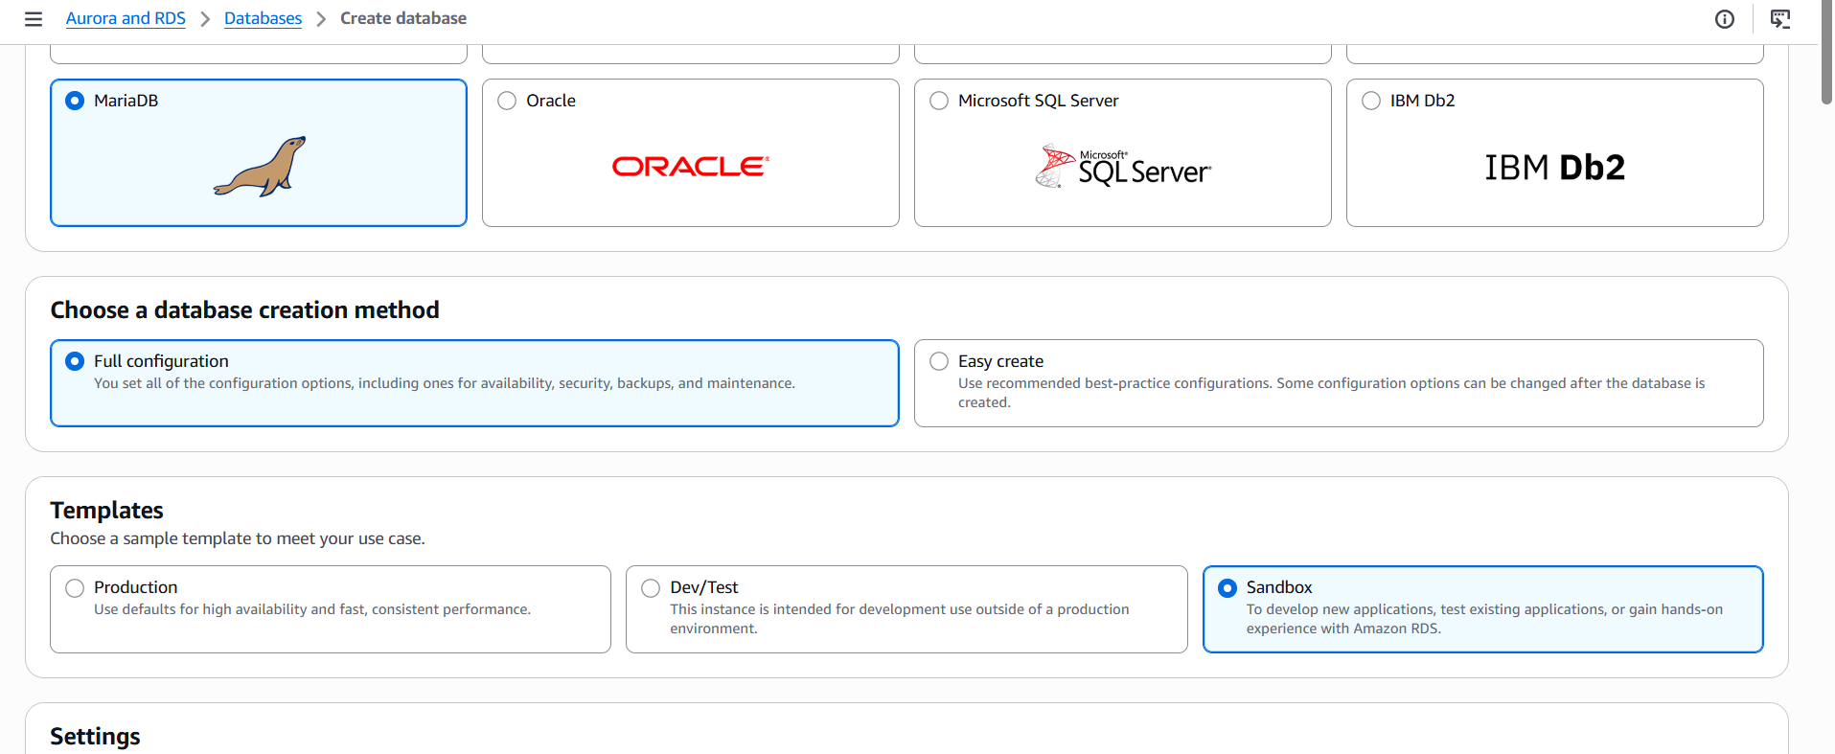
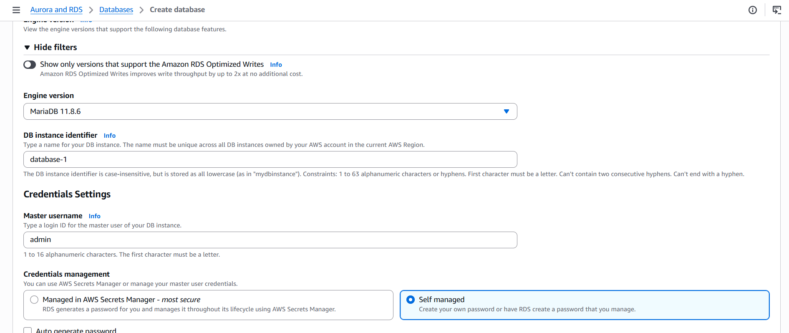
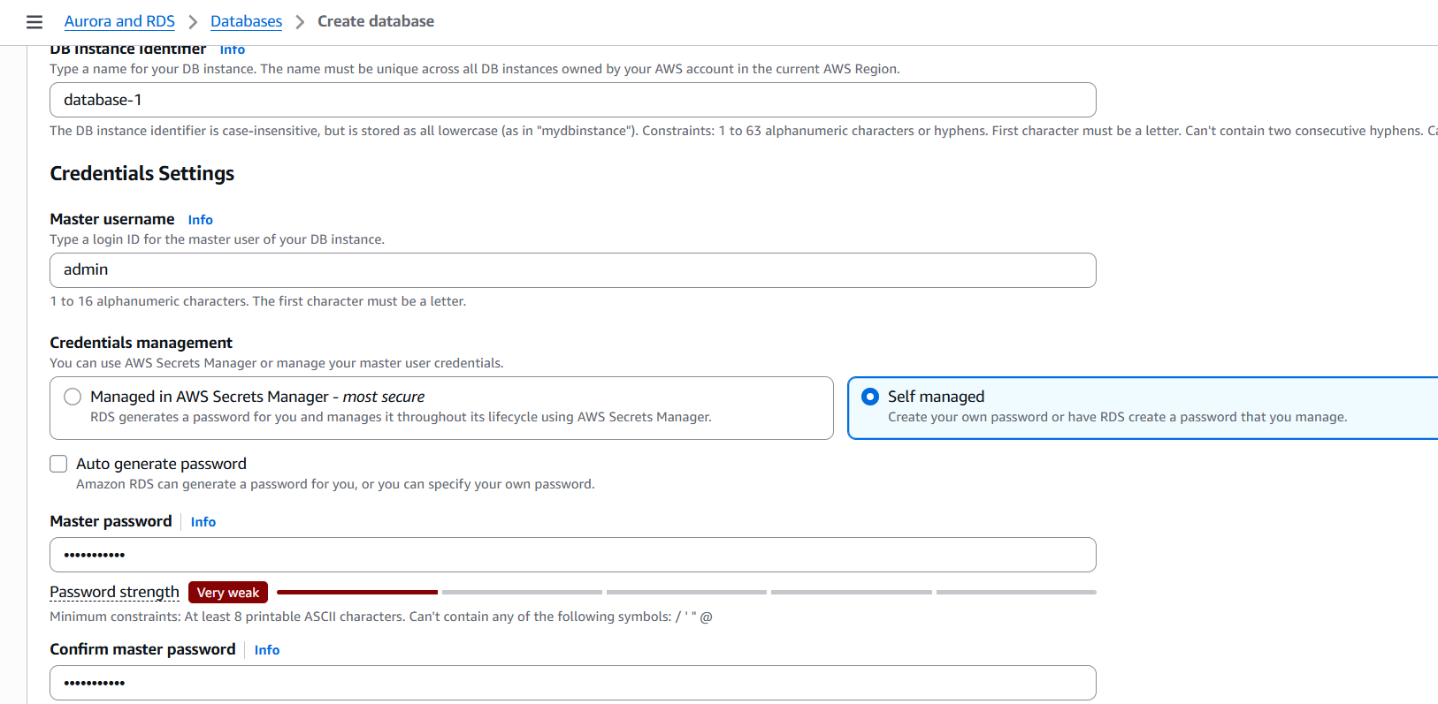
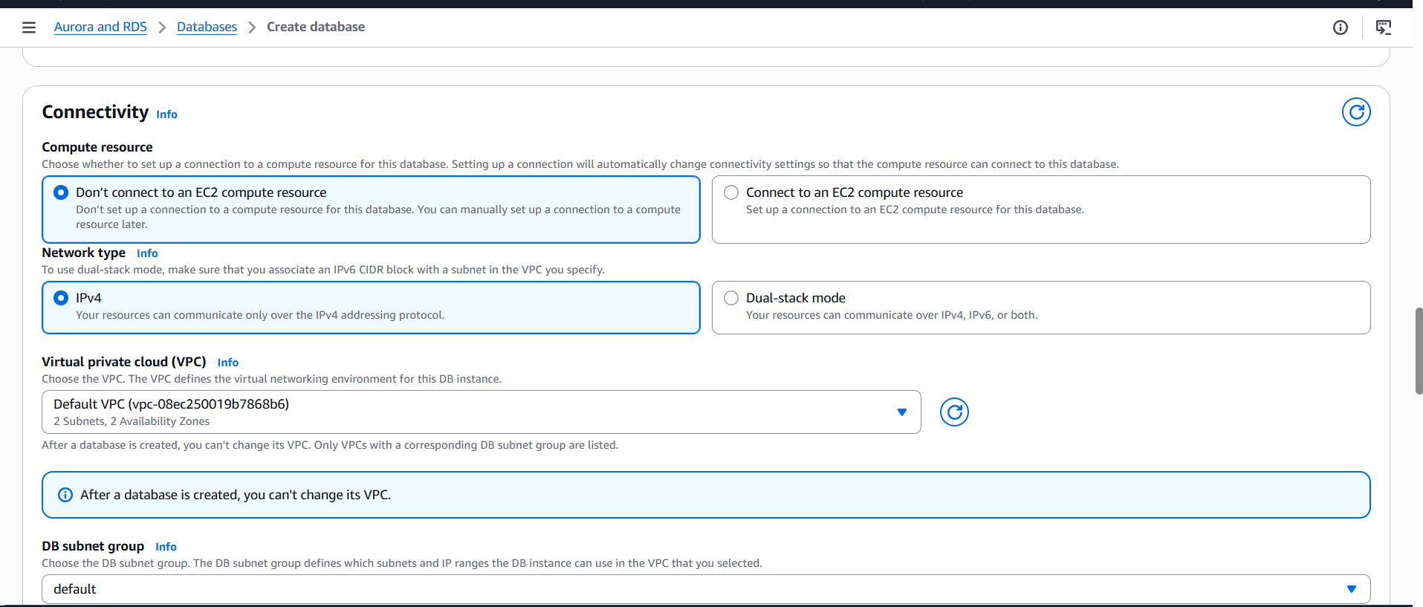
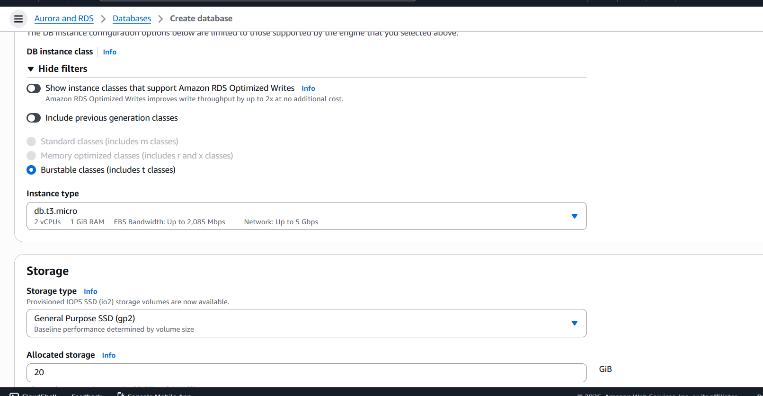
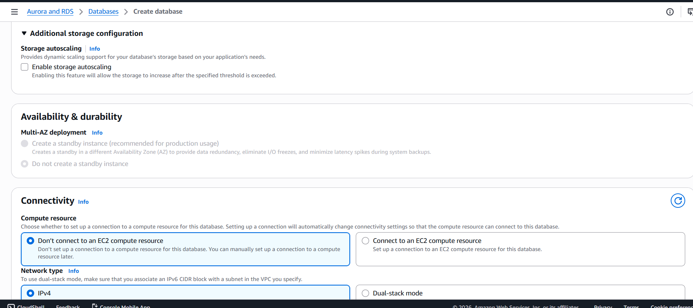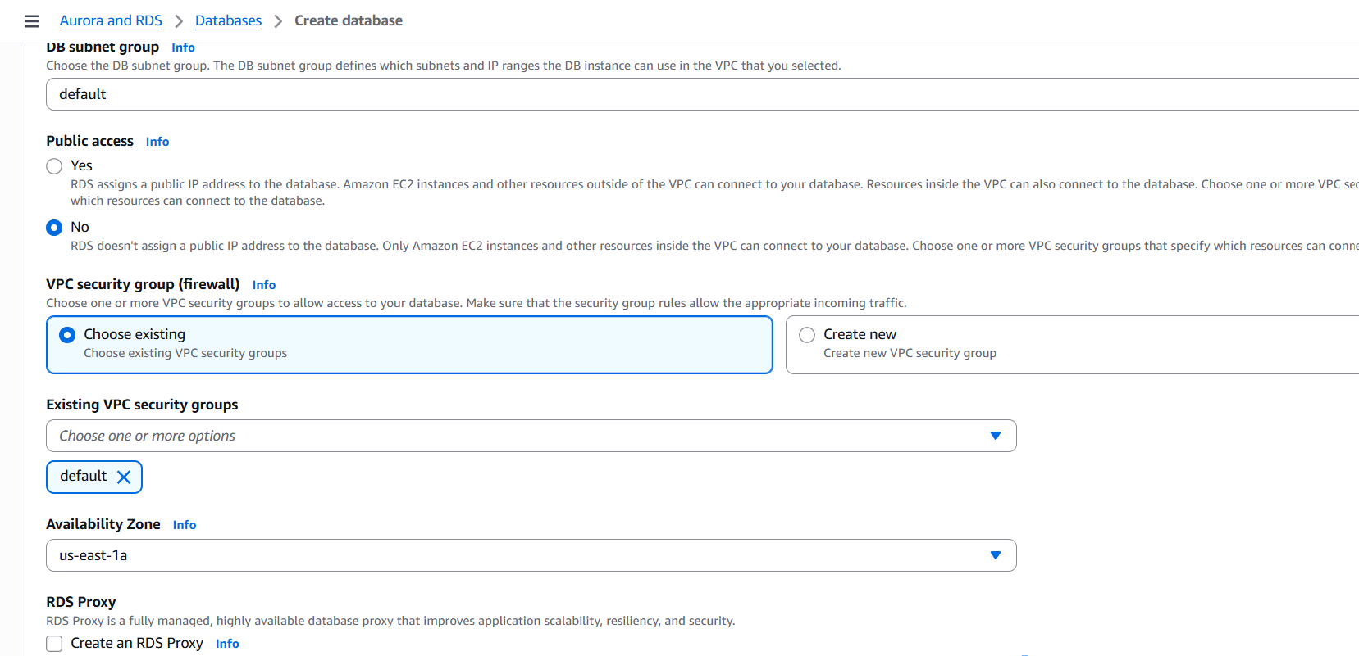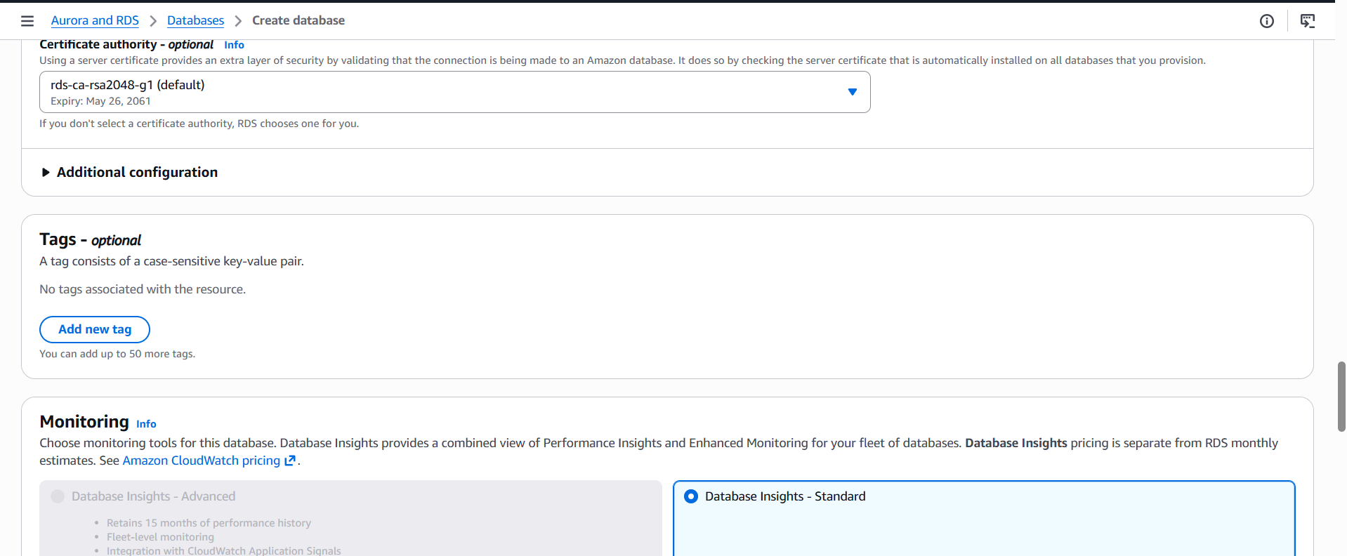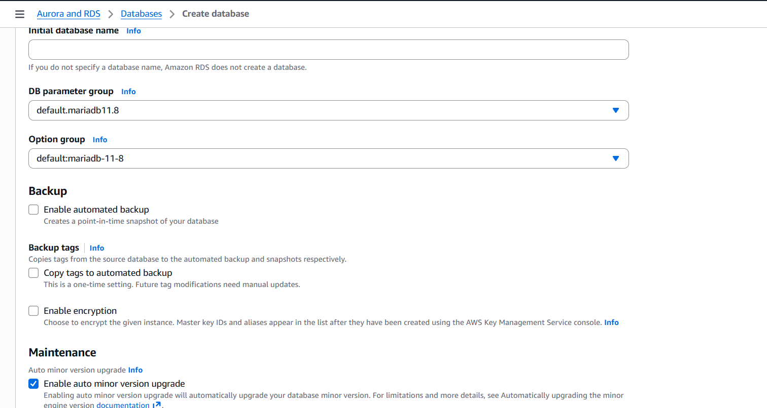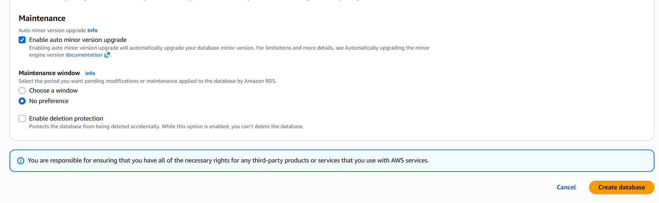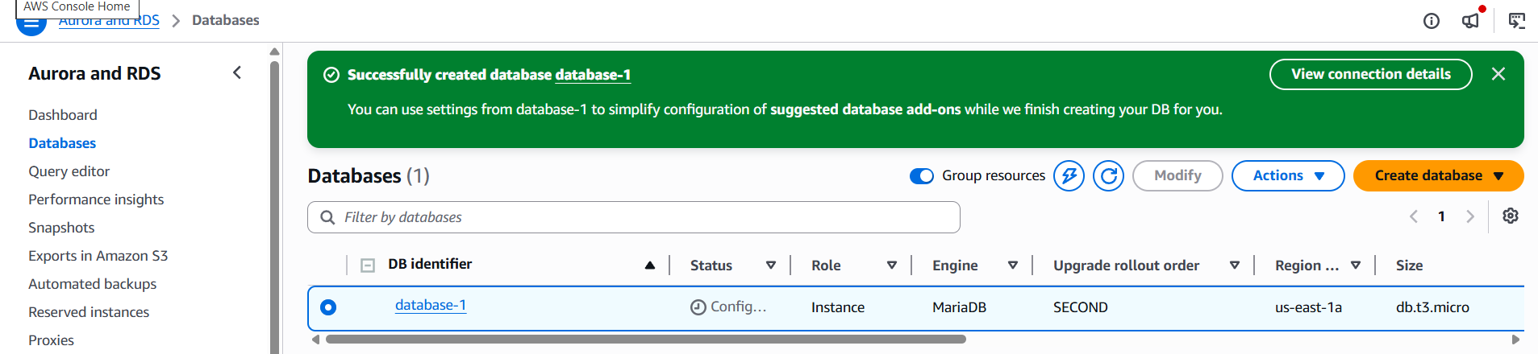
- Endpoint url copy and paste the command
- We need to add port in the security group of our instanceData Base is available now use the command
- mysql -h database-1.cc5o4w40s2bs.us-east-1.rds.amazonaws.com -P 3306 -u admin -p --ssl
- Ssl isused forsecuring the connection
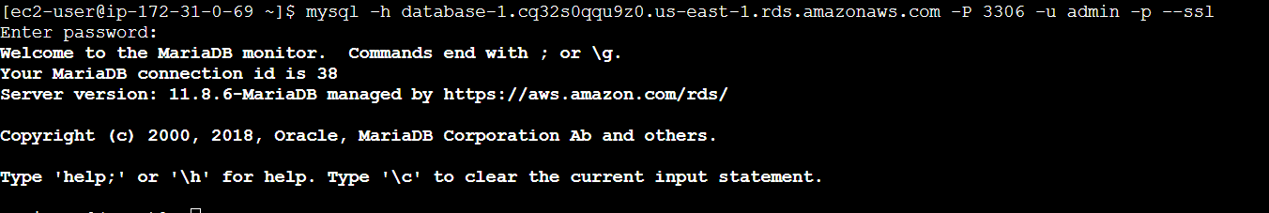
- We can see what what databases are their by using SHOW DATABASES; from our ec2 instances.
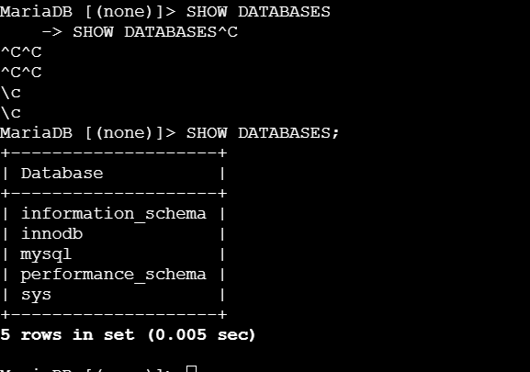

- Migrate database from EC2 to RDS.
- Will create a backup database and use the mysql command with where the data
needs to go to get the database from ec2 rds

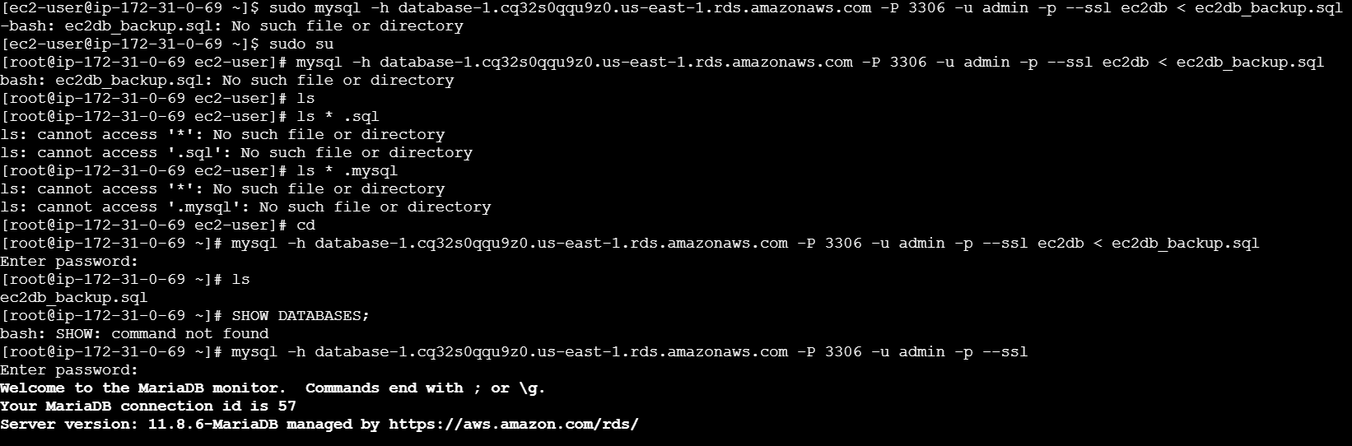
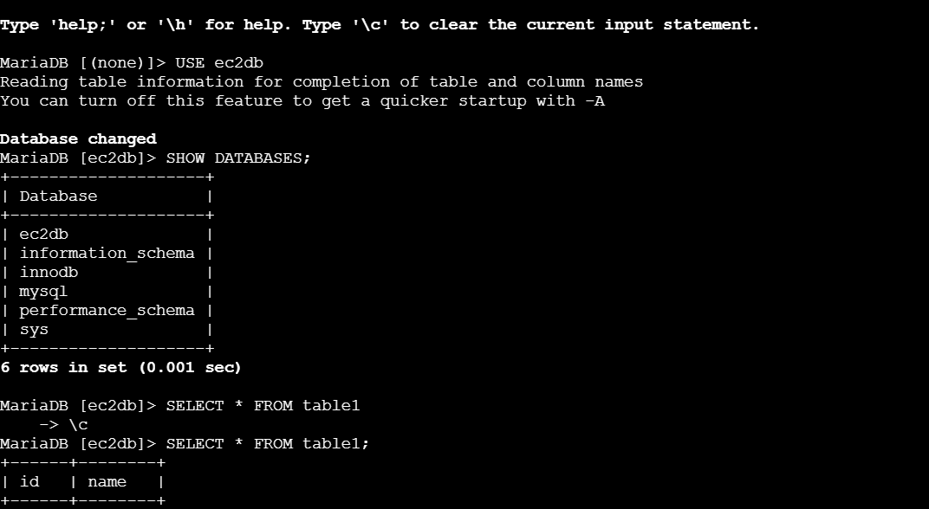
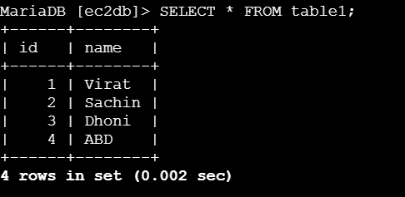

- Install MySQL DB on EC2.
- We are now able to access my sql db
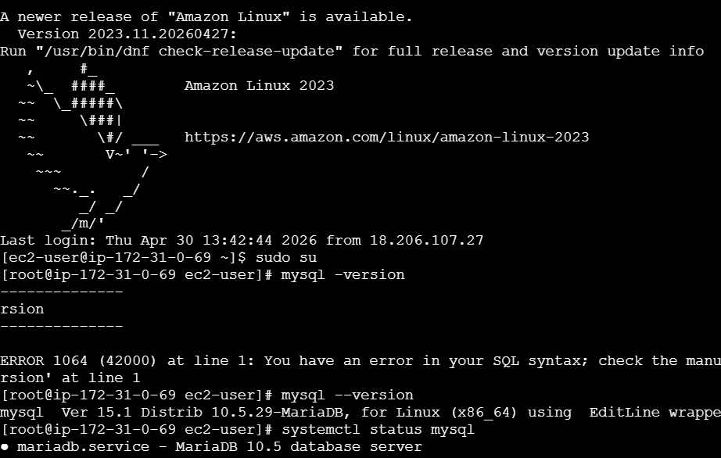
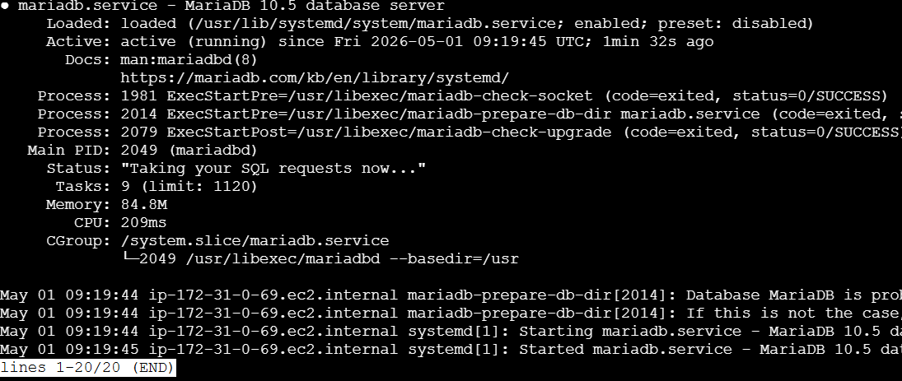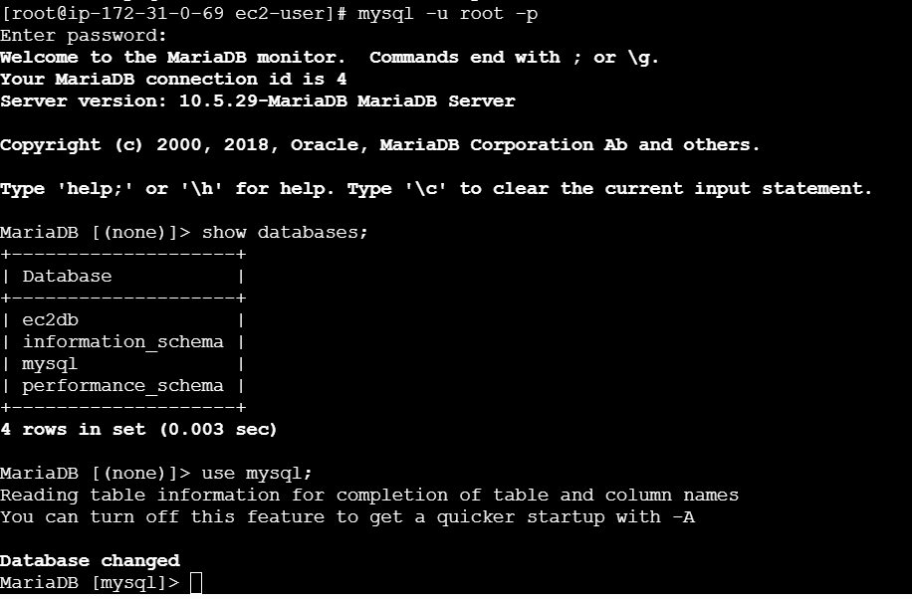
- Launch MySQL RDS image.
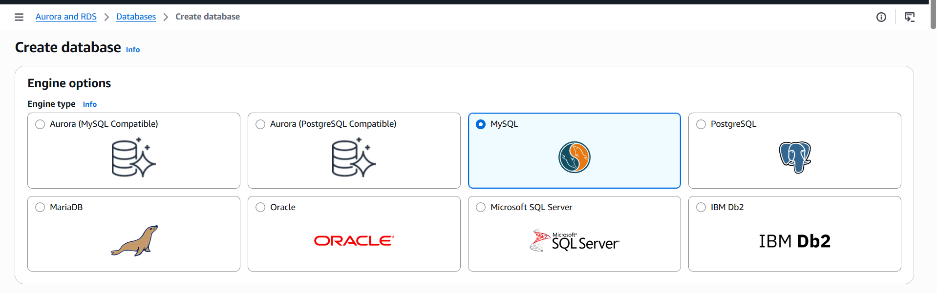
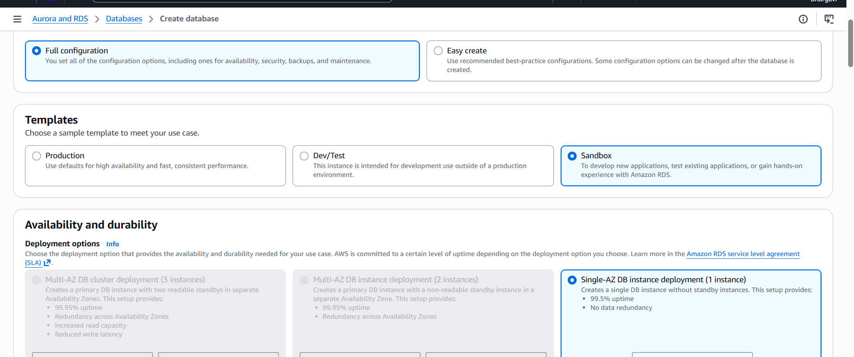
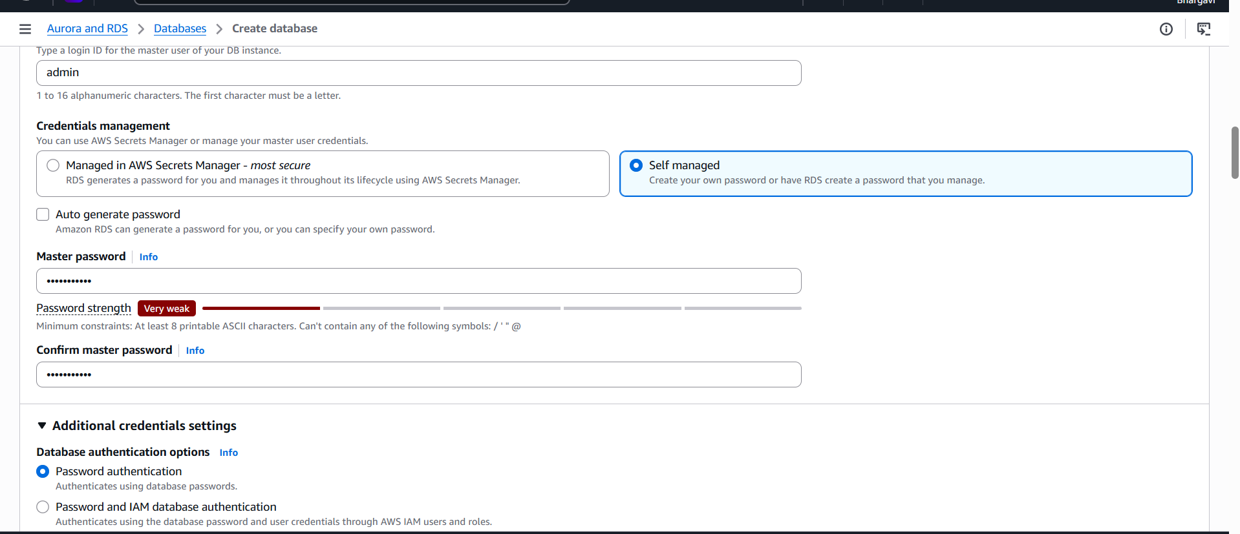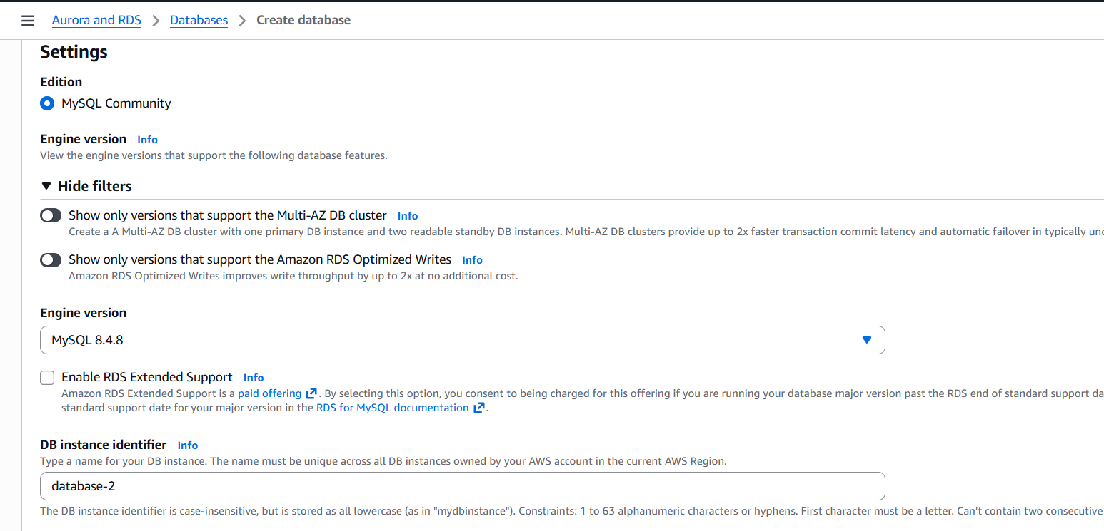

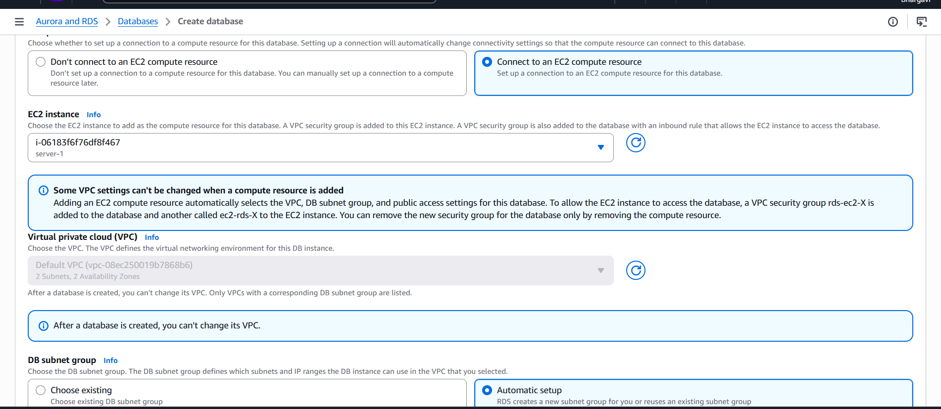
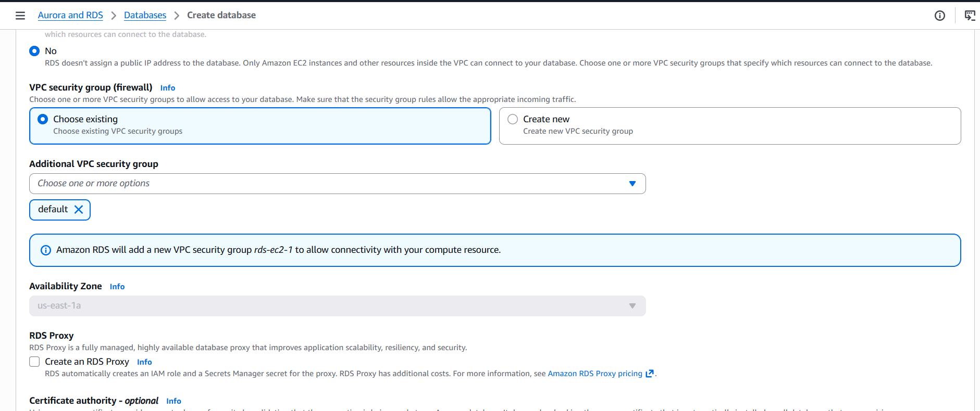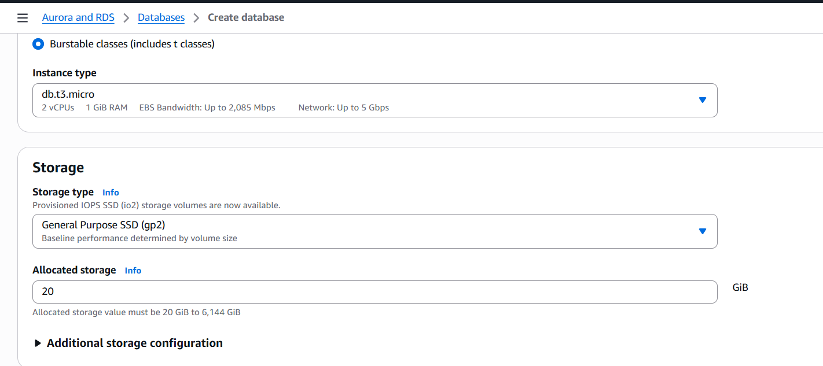
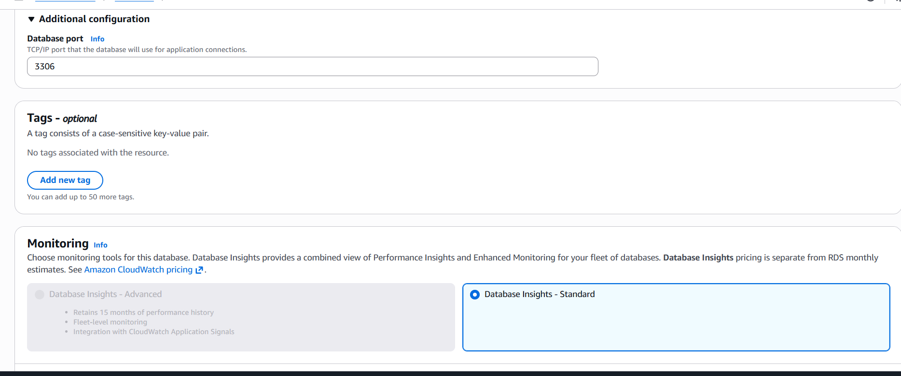
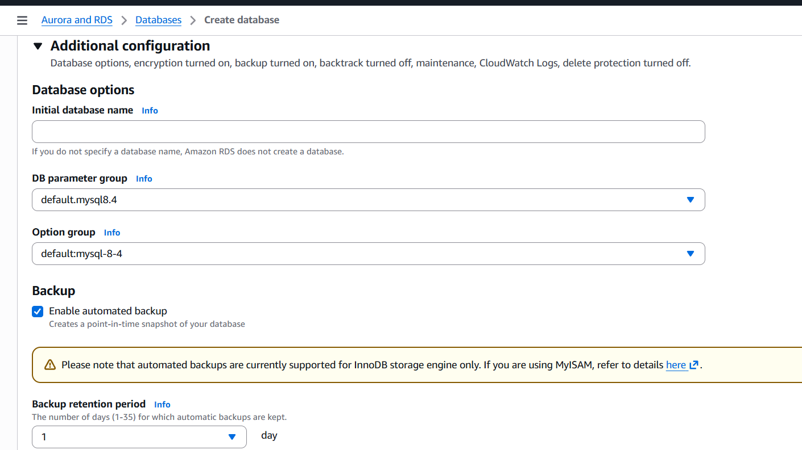
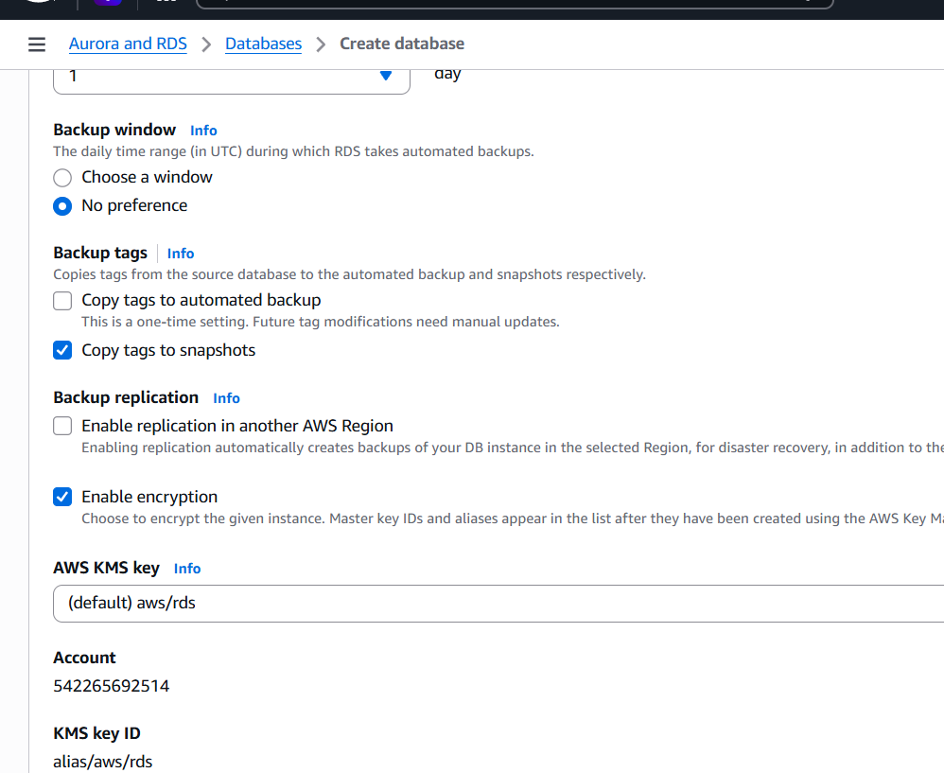
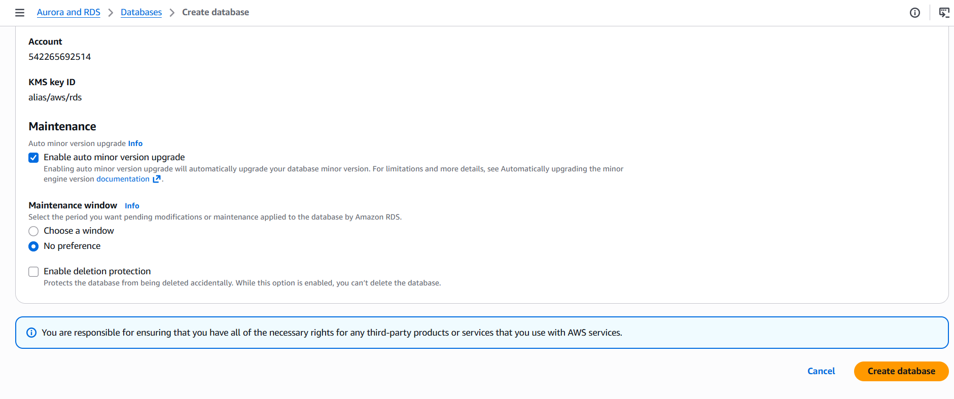
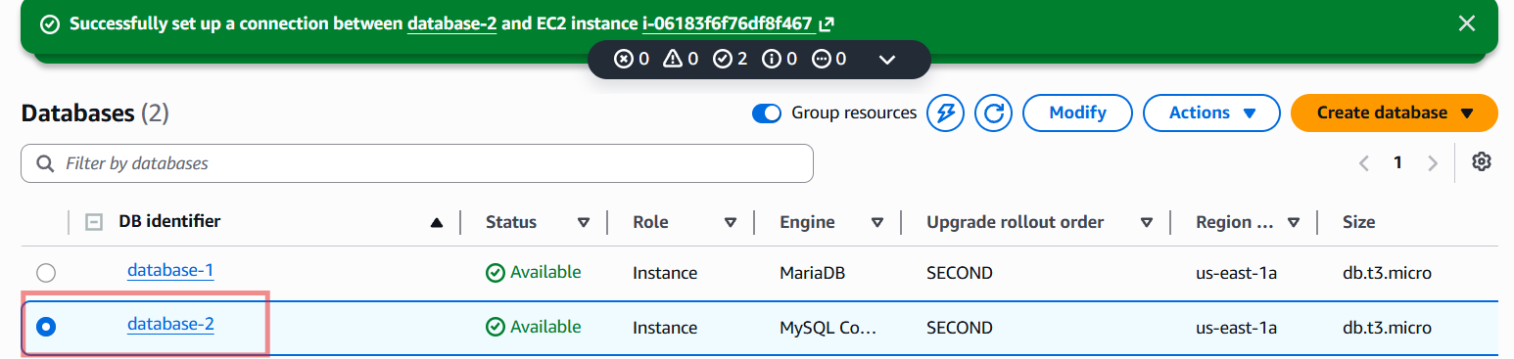
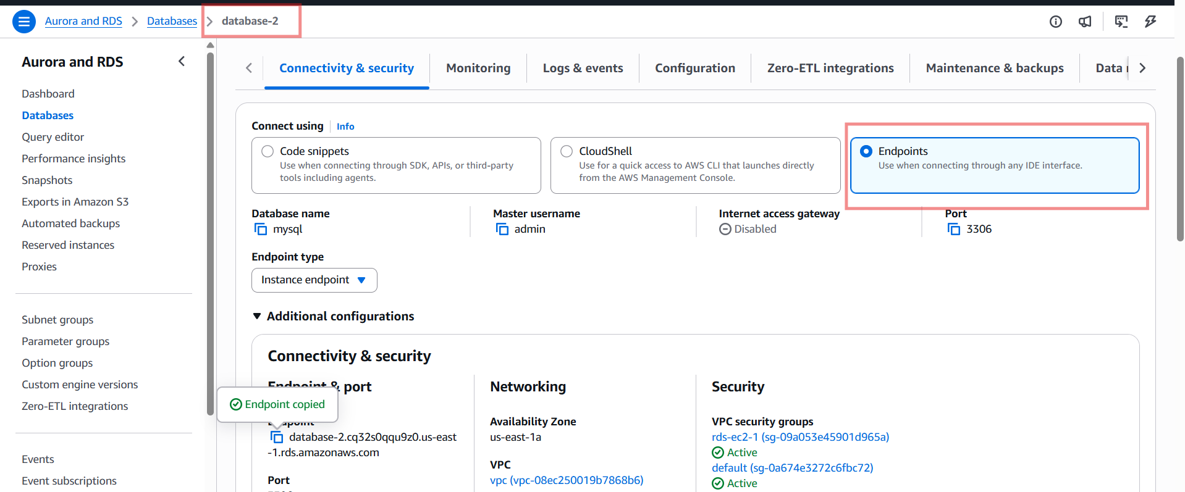
Connected from ec2
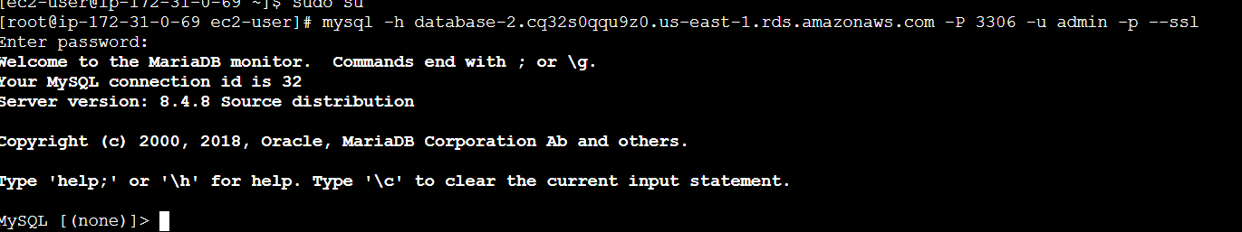
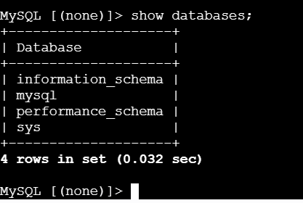
- Configure Multi-AZ.
- While creating RDS Instance we need to enable Multi-AZ
- As I am using free tier I am unable to opt it.

- Take backup of DB and restore the DB.
- Go to database → click on action → click on snapshot assign snapshot name
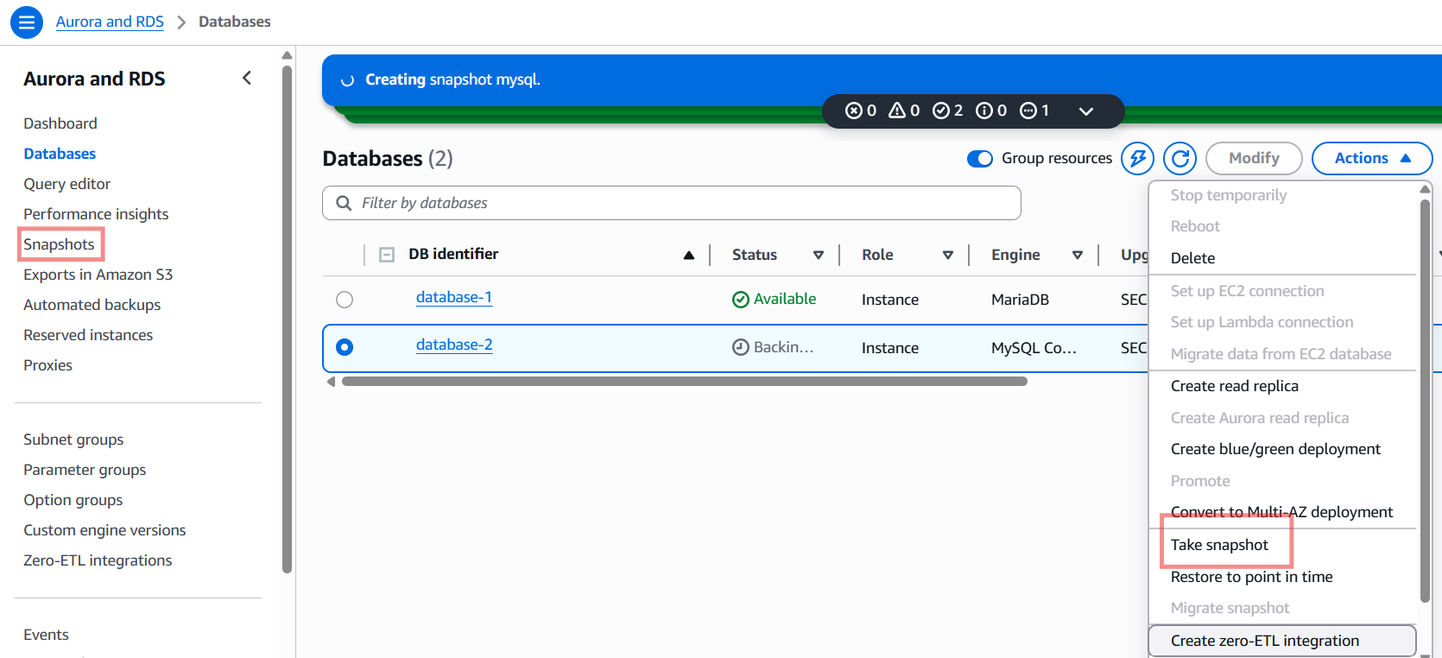

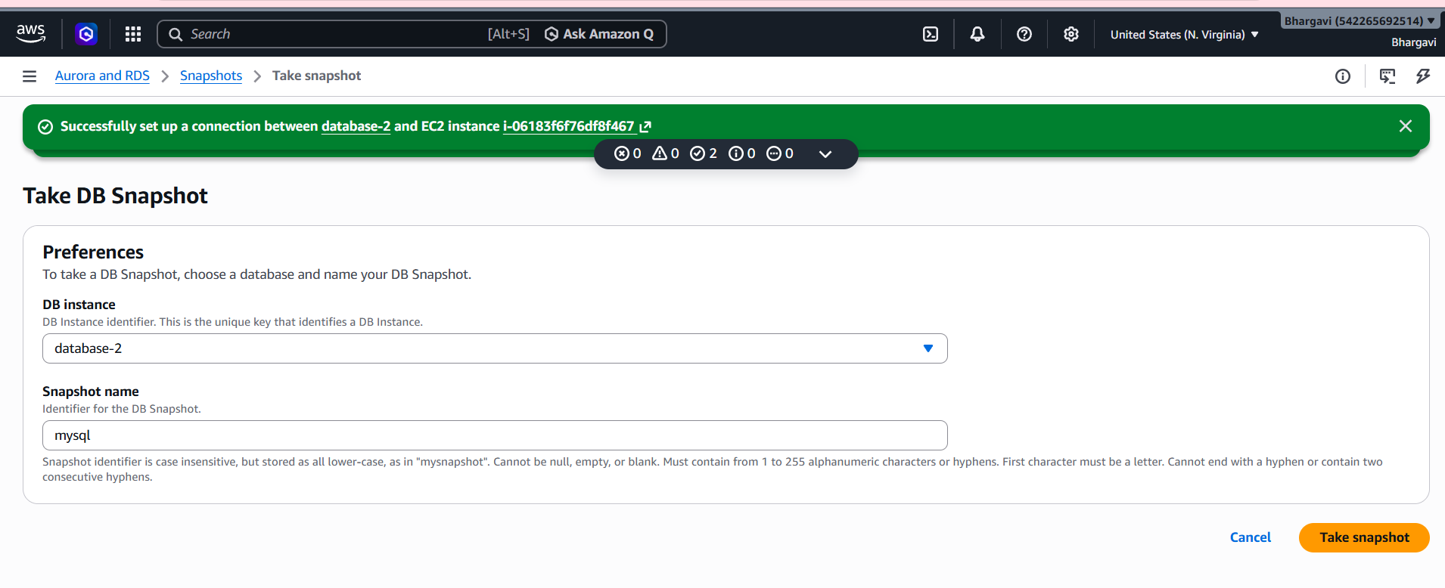
- If we have to create snapshot here endpoints will be changed everytime .soo if we want connect with new endpoint only.
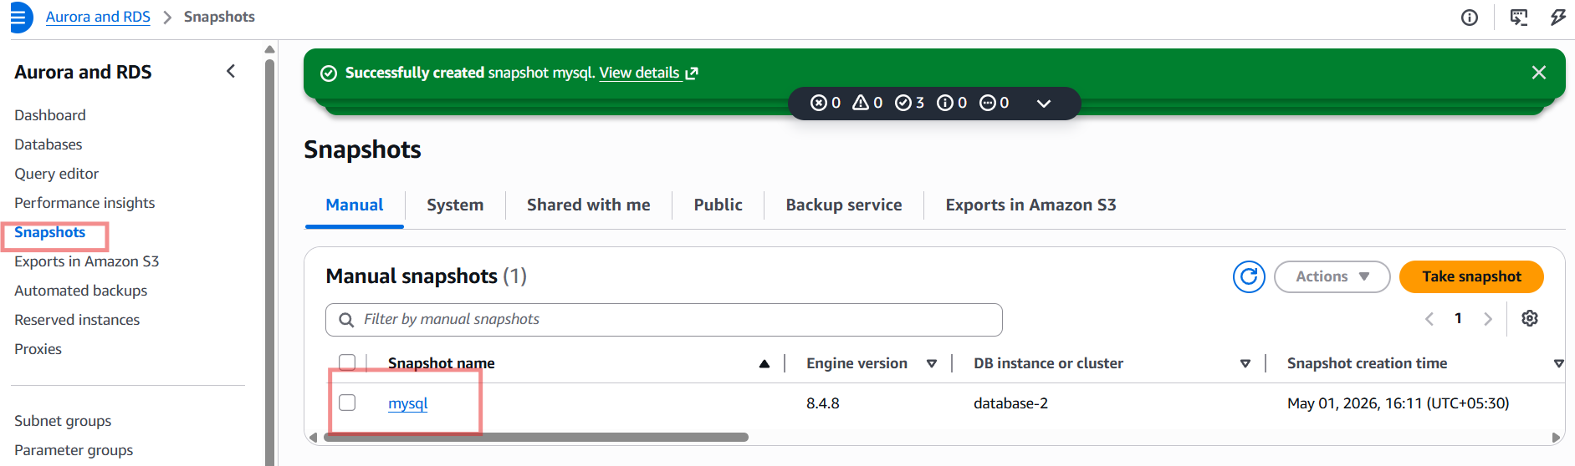
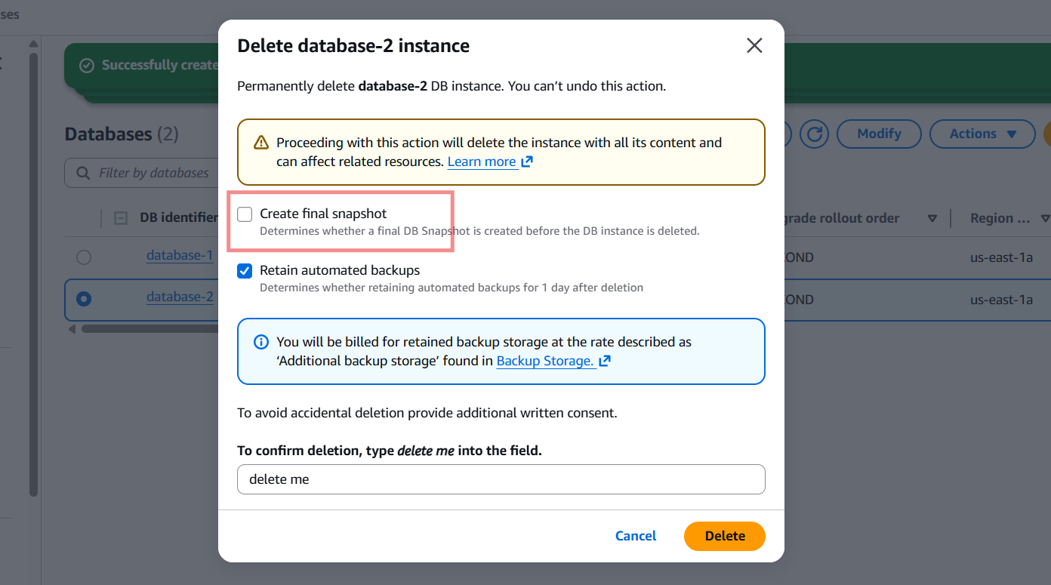
Now I want to delete the database-2 with already taken snapshot.
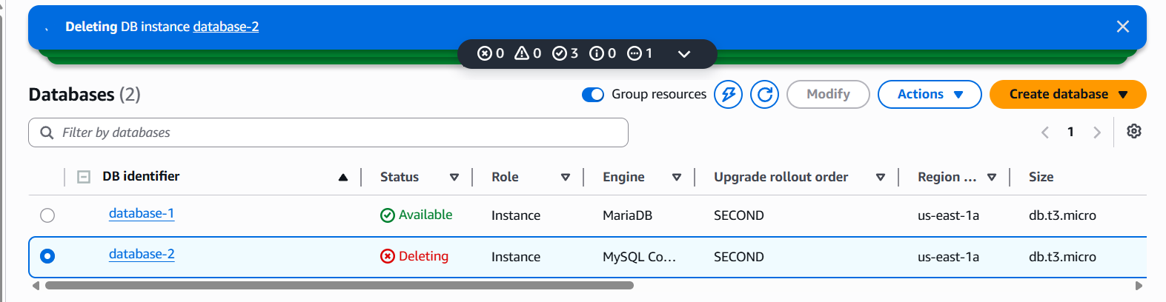
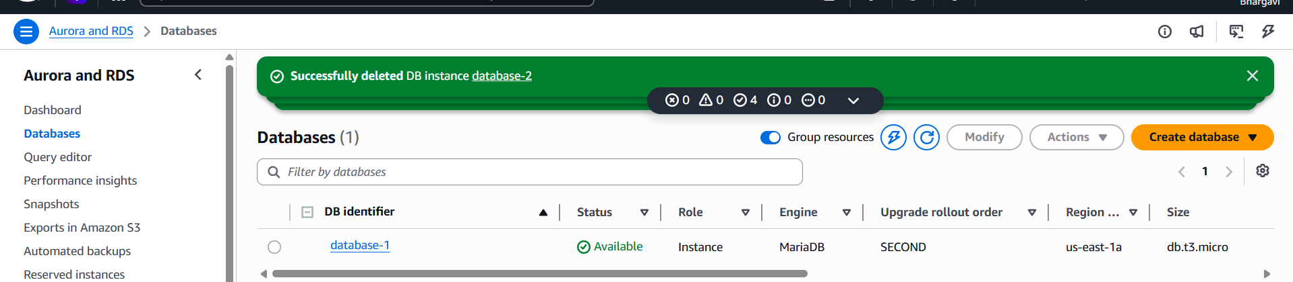
Want to restore the snapshot
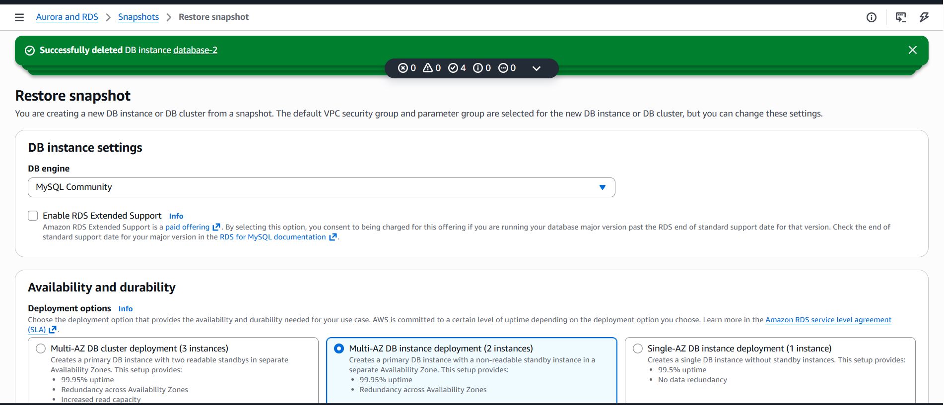
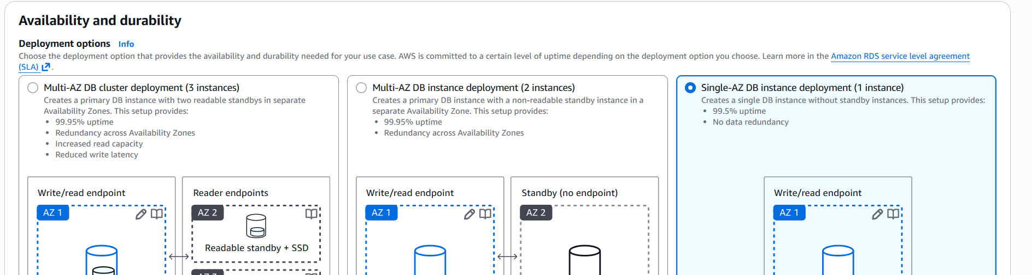
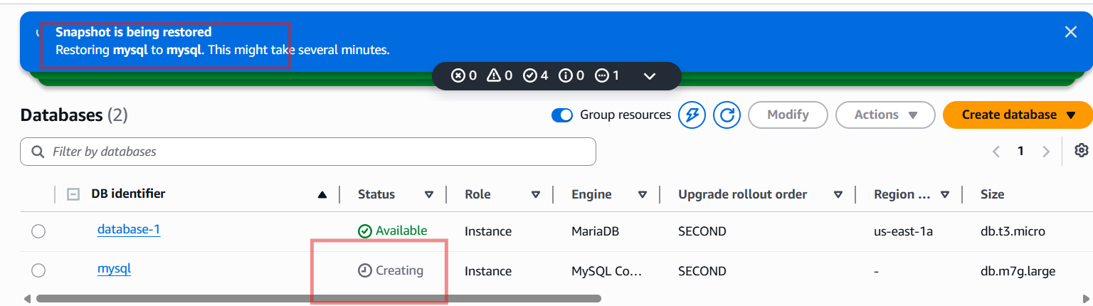
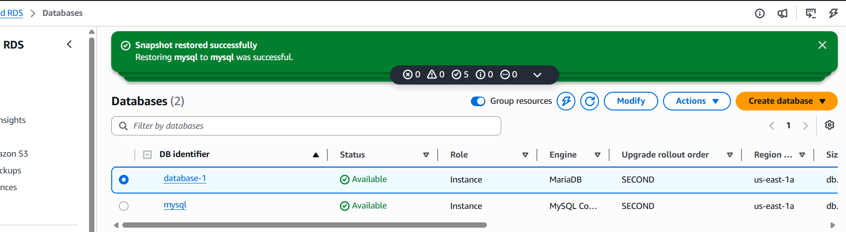

- Create read replica.
- click on database click on actions create read replicaread replica is now accessible by its endpoint and we are able to read the content of database.

